**NOTRE DAME UNIVERSITY BANGLADESH**



Lab Report

Computer Networks

Submitted to: Dr. Fernaz Narin Nur

Submitted by: Shazidul Alam

ID: 0692220005101009

Batch: CSE-19

**Introduction**

The practical lab class on computer networks was conducted by Mazhar Sir, where we explored essential networking hardware components and their functionalities. The session focused on understanding and working with cables, connectors, and network devices, which are crucial for establishing and maintaining network infrastructure.

**Objective**

The objective of this lab session was to familiarize us with various networking hardware, understand cable structuring and organization, practice cable punching and testing, and learn the basic setup of a TP-Link router.

**Networking Hardware**

Mazhar Sir introduced us to various networking components, including Cat6 cables, cable connectors, cable puncher, cable tester, router, and switch.

**a) Cat6 Cables**: Cat6 cables are high-performance Ethernet cables designed for gigabit and 10-gigabit network speeds. They offer reduced crosstalk and improved signal quality over longer distances compared to older standards.

**b) Cable Connectors**: Cable connectors, such as RJ45, are used to terminate Ethernet cables for connecting to routers, switches, and network ports. They ensure a secure and proper electrical connection between network devices.

**c) Cable Puncher**: A cable puncher is a hand tool used to insert and secure individual wires into patch panels or keystone jacks. It helps organize and maintain strong, consistent cable terminations in structured cabling systems.

**d) Cable Tester**: A cable tester checks Ethernet cables for continuity, wiring correctness, and signal integrity. It quickly identifies mis-wiring, shorts, or open connections to ensure reliable network performance.

**e) Router**: A router connects multiple networks and routes data between them, typically linking a local network to the internet. It can also manage IP addresses, firewall rules, and wireless connectivity.

**f) Switch**: A switch connects multiple devices within a local area network (LAN), enabling them to communicate efficiently. It forwards data only to the device it’s intended for, reducing unnecessary traffic.

**Components Image**

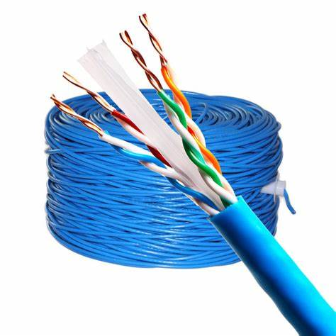 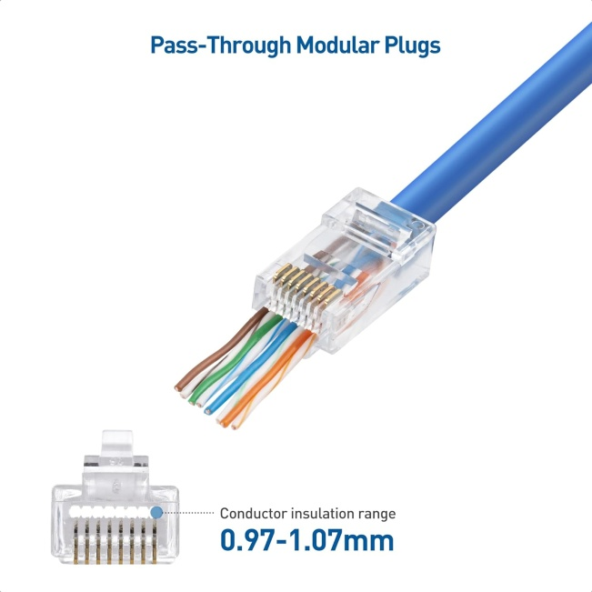

(Cat6 Cable) (Cable Connector)

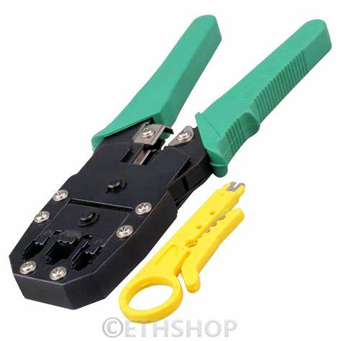 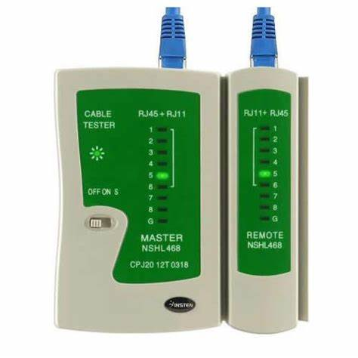

(Cable Puncher) (Cat6 Tester)

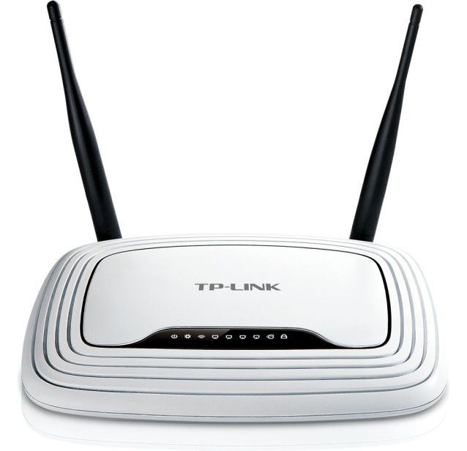 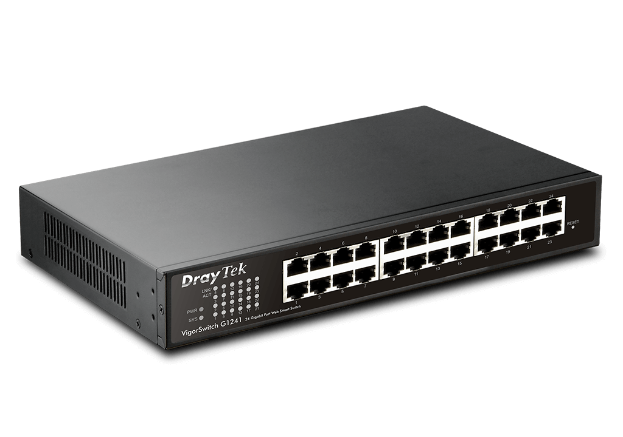

(Router) (Switch)

**Details**

**1) Cable Cutting and Organization**

We learned how to cut network cables using a puncher.

We organized the cable wires according to the standard color code:

White-orange, orange, white-green, blue, white-blue, green, white-brown, brown.

**2) Punching and Testing Cables**

After organizing the wires, we inserted them into the connectors and used a puncher to secure them properly.

We tested the functionality of the cables using a Cat6 cable tester to ensure proper connectivity.

**3) Router Setup**

We configured a TP-Link router, understanding the basic settings required to establish a network connection.

**4) Hands-on Practice**

After the demonstration by Mazhar Sir, we practiced each step individually to reinforce our learning.

**Conclusion**

This lab session provided valuable hands-on experience in working with networking hardware and understanding the basic principles of network cable structuring and router setup. The practical exposure enhanced our confidence in handling networking equipment and preparing functional network cables.